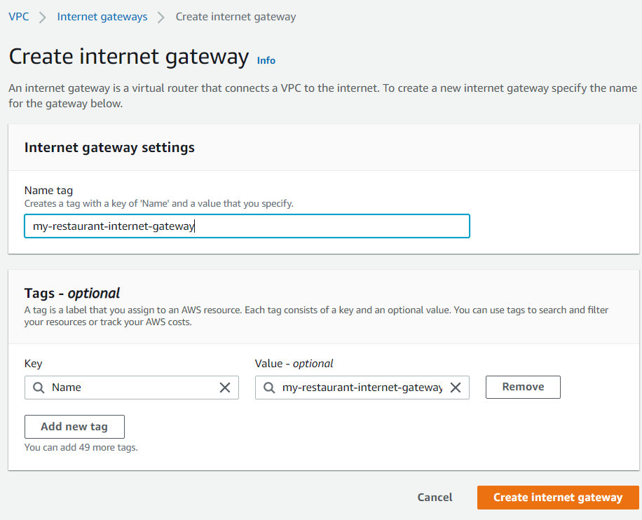

Then click on the IGW -> Actions -> Attach to VPC and attach to the restaurant VPC

